**TRACTION IN ORTHOPAEDICS**

**Uses of traction**

1. To reduce a fracture or a dislocation.
2. To retain the fracture after reduction.
3. To overcome the muscle spasm.
4. To control movement of an injured part of the body and to aid in healing.

**Methods of Traction**

* There are four methods of applying traction, namely

1. Skin
2. Skeletal
3. Pelvic
4. Spinal

**Skin Traction**

**Introduction:**

* Traction is applied over a large area of skin
* Maximum weight that can be applied through skin traction is 15 lbs or 6.7 kg.
* If the weight used is more than this, the traction will slide down peeling off the skin.
* Other difficulties such as migration of the bandage may occur with lower weights.
* When used in fracture, skin traction is applied to the limb distal to the fracture site.

**Types of skin traction**

1. **Adhesive skin traction:** adhesive material is used for strapping which is applied anteromedial and posterolateral on either side of the lower limbs.
2. **Nonadhesive skin traction:** Useful in thin and atrophic skin and in patients sensitive to adhesive strap. It is less secure than the former.

**Contraindications for skin traction**

1. Abrasions
2. Lacerations
3. Impaired circulation
4. Dermatitis
5. Marked shortening
6. Allergy to plaster

**Complications**

1. Allergy
2. Excoriations
3. Pressure sore around the malleoli
4. Common peroneal nerve palsy

**Important skin tractions**

Bucks extension skin traction:

* This is the commoner type of traction employed for lower limbs
* It is use for temporary treatment of fracture neck femur, undisplaced fractures of acetabulum, after reduction of hip dislocation, to correct minor fixed flexion deformity hip and knee for low backache, etc.

Dunlop’s traction

* Used in upper limbs and is indicate for supracondylar fractures, intercondylar fractures of humerus where elbow flexion causes circulatory embarrassment.

Gallow’s traction or Bryant’s traction

* Used for fracture shaft femur in children less than 2 years.
* If used in children above 2 years, it causes vascular complications.

**Skeletal Traction**

**Introduction:**

* The traction is given through a metal or pin drived through the bone.
* A threaded Denham pin is preferred to prevent early loosening of the device.
* The threaded portion of the Denham pin is offset, closer to the end of the pin held in the drill chuck and should engage only the proximal cortex of the recipient long bone.
* It is useful in lower limb fractures for reducing and maintaining the fracture reduction.
* It is reserved for those cases in which skin traction is contraindicated and where the need to be applied weight is more than 5 kg.

**Pins used for skeletal traction**

Steinmann pin

* It is a rigid stainless steel pin 4 to 6 mm diameter

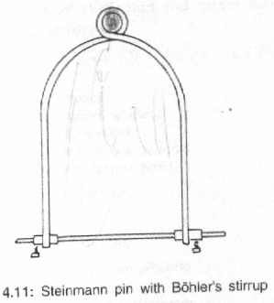

Denham pin

* This pin is threaded in the centre and engages the bony cortex.
* It reduces the risk of sliding and is useful in cancellous bone

